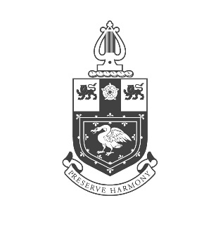
THE LORD MAYOR’S COMPOSITION PRIZE 2022
ENTRY FORM

Name
Address
Post Code Date of Birth
Telephone
Email
Title of composition

A brief explanation of the composition’s form and content

A summary of the influences on the composition

I agree to abide by the Rules & Regulations governing the Competition

Signature……………………….......................................................Date………………………………

Please ensure that you include the following with your application:

- A copy of your birth certificate  - Two testimonials/references  - The score of your work, printed single-sided on white A4 paper, unbound | - An up-to-date biography  - A photograph of you taken in the last twelve months

Your personal details will be stored on this Company’s secure database and your photograph may be used on the Company’s website and in associated publicity.
Please tick the box to confirm you have no objection to this.

Please return this completed application form and the required documentation on or before the 30th November 2022 to: The Clerk, The Musicians' Company, 1 Speed Highwalk, Barbican, London EC2Y 8DX or by email to clerk@wcom.org.uk

THE WORSHIPFUL COMPANY OF MUSICIANS, 1 SPEED HIGHWALK, BARBICAN, LONDON EC2Y 8DX
TEL: 020 7496 8980 E-MAIL clerk@wcom.org.uk WEBSITE: www.wcom.org.uk
REGISTERED NUMBERS of the CHARITABLE FUNDS 310040 & 264303 VAT 162 1105 58

