July 2022
Dear Applicant,

John Clementi Collard Fellowship – Direct Application

Thank you for responding to the Company’s invitation to apply for the John Clementi Collard Fellowship. As you might expect, the opening-up of this Award, which was formerly only available to those nominated by Principals of Conservatoires or by certain University Professors, has created a huge amount of interest. The Fellowship Committee, while not wishing to discourage any applicant, is concerned that only musicians who genuinely meet the two main criteria (early excellence and mid-career difficulties) should apply. What your two referees have to say about you will carry considerable weight, and you will note that they are being asked some searching questions.

Please complete the Application Form informatively, using extra sheets of paper if necessary, but being as concise as possible. You may attach a copy of a separate CV if you wish. Please include a photocopy of your birth certificate or passport, which will not be returned. If you are short-listed for interview you will need to bring with you your original birth certificate or passport. Interviews will take place in London on 6th December 2022.

The closing time and date for applications is 12.00 noon on 1st November 2022. Your application, together with all the additional material (please see the Application form for details), must be delivered to the Clerk’s Office by post or (preferably) by email before then, and no extensions will be allowed.

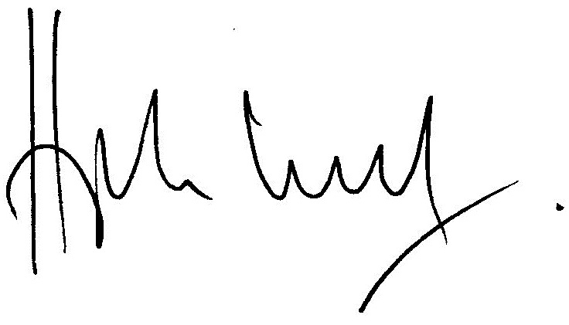

Hugh Lloyd
Clerk

THE JOHN CLEMENTI COLLARD FELLOWSHIP IN MUSIC

APPLICATION FORM

1. Candidate’s full name:

2. Professional name (if different from above):

3. Address: |  |  |  | 4. Tel. no.:  5. Email address:
6. Date of birth: |  |  |  | 7. Place of birth:
8. Marital status:

9. What is your field of music?

10. Employment status (please tick box):
 | a) Employed | □ | Who is your employer?
 | b) Self-employed | □
If you need more space for the following questions, please use additional sheets.
11. What are your present activities?

12. Education:

13. Describe your music career:

14. What have been your special achievements?

15. Describe your mid-career frustrations and problems and how the Fellowship could alleviate them:

16. How would you use the Fellowship?

17. What are your ultimate aspirations in your musical career?

18. Please give the names of your two referees:
 |  | 1.
 |  | 2.
NB. You must give to each of them a copy of the ‘Note to referees’
and a copy of the Regulations
19. How did you hear about the John Clementi Collard Fellowship?

Please ensure that you submit your form by 1st November 2022 together with the following:
- A photocopy of your birth certificate or passport
(the original of the above is to be brought to the interview if offered one)
- a recent score composed by you
OR a recent recording of a performance by you
OR a copy of a research paper recently written by you (or a meaningful extract)

Your referees may submit the references directly by email to clerk@wcom.org.uk

THE WORSHIPFUL COMPANY OF MUSICIANS, 1 SPEED HIGHWALK, BARBICAN, LONDON EC2Y 8DX.
TEL: 020 7496 8980 E-MAIL: clerk@wcom.org.uk WEBSITE: www.wcom.org.uk
REGISTERED NUMBERS of the CHARITABLE FUNDS 310040 & 264303 VAT: 162 1105 58

THE JOHN CLEMENTI COLLARD FELLOWSHIP

Note to Referees

Thank you for agreeing to write a Testimonial for a candidate for the John Clementi Collard Fellowship.

This Fellowship is one of the Worshipful Company of Musicians' most prestigious awards; it ranks among one of the more valuable awards in the world of music, and is restricted to British nationals.

For this reason the Committee is expecting a great number of applications and the Testimonials will be of the greatest importance in assisting the Committee to shortlist candidates for final interview.

The candidate will give you a copy of the Regulations relating to the Fellowship, which explain the purpose of the award.

In your testimonial, would you please state how long you have known the candidate, and whether you can attest from your own knowledge to his or her excellence in the early stages of the candidate’s career.

The Committee needs to have some information about the frustrations and problems which are preventing the candidate from reaching the creative, artistic or scholastic standards which he or she ought to be able to attain in mid-career. If there is any information which you can provide on this subject, please do so. In addition, please give us your estimate of what the candidate’s ultimate potential in his or her field could be, if assistance such as the Collard Fellowship were made available.

Please return the Testimonial in a sealed envelope to the Candidate, or by email to the Clerk, Hugh Lloyd, at clerk@wcom.org.uk . It will of course remain a confidential document for the sight of members of the Collard Fellowship Committee only. The closing date for applications is 1st November 2022 at 12.00 noon.

